**INTRODUCTION**

This narrative report documents my On-the-Job Training (OJT) experience, a crucial part of my academic journey designed to provide practical exposure to real-world professional settings. Throughout this training, I had the opportunity to apply the theoretical knowledge and skills acquired in the classroom to actual tasks and responsibilities within a professional environment. This experience not only allowed me to gain practical insights into the industry but also helped me develop essential skills, both technical and interpersonal, that are necessary for my future career. The OJT program served as a bridge between academic learning and the realities of the workforce, giving me a deeper understanding of my chosen field and equipping me with the competence and confidence needed to succeed in my future endeavors.

**Objectives On-The-Job Training**

The objective of On-the-Job Training (OJT) is to provide students with practical work experience in a real-world professional environment, enabling them to apply the theoretical knowledge they have learned in the classroom to actual tasks and responsibilities in the workplace. Through OJT, students aim to gain practical experience and enhance their skills and knowledge relevant to their field of study. It also allows them to develop professional competence by improving work-related skills such as communication, problem-solving, and teamwork.

Additionally, OJT helps students adapt to a professional environment, giving them an understanding of workplace dynamics, culture, and expectations. It also presents opportunities for networking and building connections with professionals, which could lead to future employment. By bridging the gap between theory and practice, OJT enhances students' understanding of the industry and prepares them for the realities of their chosen careers. Ultimately, the experience helps improve their employability, making them more competitive in the job market as they acquire hands-on experience that will aid in a smoother transition from academic life to professional careers.

**Significance of On-The-Job Training**

The significance of On-the-Job Training (OJT) lies in its ability to bridge the gap between theoretical education and real-world practice, making it a vital component of professional development. OJT provides students and trainees with hands-on experience, allowing them to apply what they’ve learned in the classroom to practical situations within the workplace. This experience is crucial for developing industry-specific skills, improving problem-solving abilities, and gaining a deeper understanding of their chosen field.

OJT also plays a key role in enhancing employability by familiarizing students with the expectations and culture of the professional environment. It allows them to build a network of contacts and gain insights into potential career paths, often leading to job offers or recommendations. Furthermore, OJT helps trainees cultivate soft skills such as teamwork, communication, and time management, which are essential in any career.

In essence, OJT is significant because it prepares individuals for the demands of the workforce, making them more competent and confident professionals. By providing real-world experience, it ensures a smoother transition from academic life to a successful career, ultimately increasing their chances of long-term success in their chosen industry.

**Time and Place of On-The-Job Training**

The On-The-Job Training took place from 8:00 PM to 8:00 AM in a hybrid setup, combining both remote and in-office work environments. This flexible arrangement allowed for participation from different locations, providing a balanced experience of both remote work dynamics and traditional office settings.

**THE LINKAGE ESTABLISHMENT**

**Location of the Establishment**

JBR Building B11 L25 Greenbreeze Ave. Cor. Brazil St. Greenbreeze Village 1, Langkaan 2, Dasmariñas City, Cavite 4114

**Background/Profile of the Establishment**

PENDRAGON I.T. BUSINESS SOLUTIONS started last August of 2015 under the name of Mithril BPO. We started with 8 shareholders, 5 which are active and the other 3 as observers. 2 of the shareholders dropped out by November 2015 since they are unable to provide their promised investment. However, 1 investor came in by December 2015 which made a total of 6 Primary Investors. By January 2016 the other 4 investors dropped out and left the other 3 Primary investors. The remaining 3 Investors continued to support the Company and by April 2016, we were able to work for a Canadian Charity Company that boosted the Company’s Revenue and made calls for them until April 2017. We had to let go of the client after a year since they want to pay less than usual. Last April 2017 there were only 2 remaining Primary Investors left. We then decided to change the name to Sapphire BPO with more than 10 agents and have run different voiced and non-voiced campaigns. In 2019 we had to change the name to Pendragon IT Business Solutions as we tried to cater to setting up websites and providing IT Business Solutions to small businesses around Dasmariñas Cavite. In the early 2020 when the pandemic and lockdown happened in the Philippines, Pendragon IT Business Solutions was left with 1 back-office campaign. All other campaigns and IT Business Solutions projects had to file for bankruptcy. We were forced to close our office and do the back-office campaign at home for 2 and a half years. August 2022, a new business opportunity came. We were able to come across a Legitimate campaign broker, but we don’t have the funds to set up an office and pay for the campaign retainer fee w/c was 8,000 usd. In September 2022 we met Alladin De Lapa and started a new business partnership venture for the new call center that we established.

**Vision and Mission Statements of the Establishment**

**MISSION STATEMENT**

Our Mission and passion is to bring innovation, support, and information to the small and medium call center industry here in the Philippines. To create content that educates, informs and inspires, to find and know they have a permanent place in a industry that is and has been shaping this country to be recognize a force to be reckon with, I use this phrase “No one should be left behind”, with that being said we wanted to develop a open community portal for that to happen.

**VISION STATEMENT**

Our vision is to be Philippines's most customer & community portal; to build a place where Call Centers can come to find and discover anything they need to be recognized and supported, gather information to make their center successful.

**Function and Responsibility of the Management**

As a data entry specialist, I observed that management is vital to ensuring smooth office operations. They plan tasks, set goals, allocate resources, and organize workflows to optimize efficiency. Management leads by providing direction and support while maintaining morale. They also monitor the accuracy of work, address issues quickly, and conduct performance evaluations to help employees improve.

Training and development are prioritized to ensure employees are well-prepared, and clear communication is maintained for effective collaboration. Finally, management creates a productive and healthy work environment, focusing on ergonomics and safety. Overall, their role is key to the team’s efficiency and success.

**THE TRAINING AREA**

**Department Function**

The training area serves as a hub for onboarding, skill development, and continuous learning within the organization. Its primary function is to ensure that employees, especially new hires, are equipped with the necessary knowledge and skills to perform their roles efficiently. It also supports ongoing professional development to keep staff updated with industry trends and best practices.

**Organizational Structure of the Department**

The training department is typically organized with a Training Manager at the top, overseeing the department's operations. Under the manager are Training Coordinators or Training Specialists, responsible for developing training materials, conducting sessions, and managing logistics. They may be supported by Technical Support Staff who handle equipment setup and maintenance. In larger organizations, there may also be Training Assistants who provide administrative support.

**Facilities**

The training area features computer labs for hands-on sessions and is equipped with video conferencing technology to support hybrid setups. Breakout areas are available for group discussions and one-on-one coaching, ensuring effective engagement for both in-person and remote trainees. This setup provides a flexible learning environment for diverse training needs.

**Equipment**

The equipment in the training area includes computers or laptops for trainees, video conferencing systems for remote sessions, and training-specific software for simulations. Additionally, headsets or microphones are provided for interactive sessions. Properly maintained equipment ensures that training sessions run smoothly and efficiently.

**Standard Operating Procedures (SOPs)**

SOPs in the training area cover various aspects, such as how to schedule training sessions, manage attendance, and ensure that all training materials are up to date. Procedures typically include pre-training checklists to ensure equipment is functional, evaluation forms for collecting feedback, and follow-up protocols to assess the effectiveness of the training. Additionally, there are SOPs for maintaining a clean and organized training environment, ensuring that all health and safety guidelines are adhered to during training sessions.

**CASE REPORT**

This case report emphasizes the essential functions of management in a hybrid office environment, particularly for a data entry team. Management's role in planning, organizing, leading, controlling, and training remains crucial in both remote and in-office settings. Their involvement ensures that tasks are completed efficiently, regardless of the work location. The positive outcomes observed in this hybrid setup highlight the significant impact of effective management on overall productivity and employee satisfaction, demonstrating that strong leadership and clear communication are vital in navigating the complexities of hybrid work.

**THE TRAINING EXPIRIENCE**

During my training as a data entry specialist, I gained essential skills in data management, software tools, and efficient workflow processes. The training combined hands-on practice with theoretical knowledge, guided by supportive management who provided clear instructions and regular feedback. This experience emphasized the importance of accuracy, time management, and teamwork in data entry tasks, preparing me for a smooth transition into a full-time role.

**Tasks Performed/Specific Activities Assigned**

During my training, one of the primary tasks I performed involved verifying the license numbers of nurses registered in Missouri using a company-provided web browser application. This task required me to access the Nursys database, input the necessary details, and solve captchas to complete the verification process. Ensuring accuracy and efficiency was key, as this information was critical for maintaining up-to-date records.

**Observed Strengths and Weaknesses of the Training Area**

**Strengths:**

The training area was well-equipped with computers and video conferencing systems, facilitating seamless remote and in-person learning. The hybrid setup allowed for flexibility and efficient participation from all trainees. The supportive environment also encouraged active learning and collaboration.

**Weaknesses:**

Working 12-hour graveyard shifts was challenging, and I often found it difficult to stay alert, which impacted my focus. Additionally, the repetitive nature of tasks during training led to occasional disengagement. The lack of variety in the workstations, with limited access to ergonomic equipment, also contributed to physical discomfort during extended sessions.

**Insights**

Through my training experience, I gained a deeper understanding of the importance of adaptability in both in-person and remote work environments. The hybrid setup highlighted the need for effective communication and time management, especially when working across different shifts. I also realized the critical role of attention to detail and accuracy in data entry, as even small errors can lead to larger issues. Additionally, the experience emphasized the value of maintaining a balanced routine, as long shifts, especially during the graveyard hours, require good self-care practices to ensure productivity and focus.

**Problems Encountered**

During my training, one of the main challenges was managing the 12-hour graveyard shifts, which often made it difficult to stay alert and focused, leading to occasional fatigue. Technical issues, such as slow internet connections and system glitches in the browser application, disrupted the workflow and caused delays in completing tasks. Additionally, the repetitive nature of tasks sometimes resulted in disengagement and made it harder to stay motivated throughout long shifts. Limited access to ergonomic equipment also contributed to physical discomfort during extended working hours.

**Suggestion for Improvement**

To enhance the training experience, it would be beneficial to introduce more task variety to keep trainees engaged and simulate a wider range of real-world challenges. Implementing shorter shifts or offering more frequent breaks during long graveyard shifts could help maintain focus and reduce fatigue. Upgrading technical infrastructure, including improving internet connectivity and optimizing software performance, would significantly reduce workflow disruptions and enhance overall efficiency during training sessions. Additionally, providing ergonomic equipment like adjustable chairs and desks would improve physical comfort during extended sessions, leading to better productivity and well-being for trainees.

**LEARNING JOURNAL**

Name: Arnold N. Montañez

Date Started: August 05, 2024

Date Finished: August 10, 2024

Number of Hours: 60

|  |  |
| --- | --- |
| **Department** | **Activity/Assigned Task** |
| August 05, 2024 – August 08, 2024  Verifications Department. Encoder Position(HOMEBASED)  August 09, 2024  Verifications Department. Encoder Position(Onsite) | * On my first day of OJT, we conducted a meeting via Google Meet. We started by introducing ourselves, followed by an orientation session. After the meeting, which lasted almost an hour and started at 10:15 PM, we learned that the usual first break is scheduled from 10:00 to 10:15 based on the meeting guidelines. The objective of the work was to check the license numbers of nurses in Missouri using an app provided by the company. The app resembles a web browser, with credential fields at the top and a submit button at the bottom. My first impression is that this is a decent job, especially for interns. It's a good start for gaining experience in office work. * On the second day, we continued with the same tasks as yesterday. We encountered some issues with the CAPTCHA section, as it sometimes took almost 5 minutes to move to the next page. We reported the issue, and were informed that it's normal, but we should report it if the problem persists. * On the third day, due to the issues we encountered the day before, we suggested using the client mode. This required us to open the app twice, running two instances simultaneously. It was quite challenging to manage both tasks at the same time. * On the fourth day, we continued using the dual client mode, and I managed it a bit better. Since we were showing improvement, we were allowed to play music on YouTube or any platform we preferred. I tried watching a movie on Netflix, but found it hard to focus, so I decided to stick with playing music on YouTube instead to help alleviate some boredom. At 6 AM, we conducted a meeting via Google Meet. The supervisor wanted to meet with us, but only those who were available could attend. * On the fifth day, I brought my own PC to the office since they didn’t have one available for me to use, but that was fine. As it was our first face-to-face meeting, our supervisor treated us to pizza for a little celebration. During that day, we used the first hour of the shift for the meeting, so we started our work again at 10:15 PM. We also had a brief meeting and some casual chit-chat with my co-workers. On that day, I met two colleagues: Marvin and Japer. Japer is my cousin from my mother's side, though I'm not sure which branch he’s with. Marvin is older than both Japer and me—he's in his 30s, so we refer to him as 'sir.' |

______________________________ __________________________________

Name & Signature of Student Trainee Name & Signature of Immediate Supervisor

**LEARNING JOURNAL**

Name: Arnold N. Montañez

Date Started: August 12, 2024

Date Finished: August 17, 2024

Number of Hours: 60

|  |  |
| --- | --- |
| **Department** | **Activity/Assigned Task** |
| August 12, 2024 – August 16, 2024  Verifications Department. Encoder Position(HOMEBASED) | On my second week of my OJT, we continued our tasks from home-based. Although we faced the same errors as last week, we've been managing them more effectively now. Each day feels like we're gaining more control over the situation, and we're seeing steady progress in our license monitoring work. The initial challenges haven't disappeared completely, but they don't seem as overwhelming anymore. Overall, it feels good to be making headway, and I’m learning more about problem-solving in real time. |

______________________________ __________________________________

Name & Signature of Student Trainee Name & Signature of Immediate Supervisor

**LEARNING JOURNAL**

Name: Arnold N. Montañez

Date Started: August 19, 2024

Date Finished: August 24, 2024

Number of Hours: 60

|  |  |
| --- | --- |
| **Department** | **Activity/Assigned Task** |
| August 19, 2024 – August 23, 2024  Verifications Department. Encoder Position(HOMEBASED) | This week started with a Google Meet meeting on Monday. We had plans to work on-site, but those plans changed when Taal Volcano released smog, and we decided to continue working from home to stay safe. Despite the safety precautions, this week remained just as challenging. The errors we’ve been facing still persist, and sometimes they cause our working hours to stretch to 12 hours a day. It’s frustrating at times, as it can take an hour just to get back to work after an issue arises. But even with all of these setbacks, we're still gaining progress in our work. One step at a time. |

______________________________ __________________________________

Name & Signature of Student Trainee Name & Signature of Immediate Supervisor

**LEARNING JOURNAL**

Name: Arnold N. Montañez

Date Started: August 26, 2024

Date Finished: August 31, 2024

Number of Hours: 60

|  |  |
| --- | --- |
| **Department** | **Activity/Assigned Task** |
| August 26, 2024 August 28, 2024  Verifications Department. Encoder Position(HOMEBASED)  August 27- 31, 2024  Verifications Department. Encoder Position(ON-SITE) | This week marked the conclusion of my OJT journey. We kicked off Monday with a Google Meet meeting, and it was decided that starting Tuesday, we’d shift to on-site work. Since it was my last week of training, I wanted to experience the office environment and understand firsthand the differences between working remotely and in an office.  The transition to on-site work was both exciting and eye-opening. The last four days were filled with new experiences, from adjusting to the office routine to the little moments shared with my co-workers. During our free time and at the end of our shifts, we would often unwind by playing Mobile Legends together, which made the workdays feel lighter and more enjoyable.  Beyond the fun moments, working in the office taught me a lot. I realized that the energy and atmosphere in an office are completely different from working at home. I learned to appreciate the value of face-to-face collaboration, the quicker communication, and even the simple things like sharing a laugh with colleagues. This experience gave me a deeper understanding of what it’s like to be part of an office team, and it’s something I’ll carry with me as I move forward. |

______________________________ __________________________________

Name & Signature of Student Trainee Name & Signature of Immediate Supervisor

**SUMMARY**

During my On-the-Job Training as a data entry specialist, I worked in a hybrid setup from 8:00 PM to 8:00 AM, combining both remote and in-office environments. The training area was well-equipped with computers and video conferencing systems, facilitating seamless learning. I developed essential skills in data management, accuracy, and efficiency through hands-on experience and strong management support. However, challenges such as long graveyard shifts, repetitive tasks, and technical issues like slow internet affected productivity.

Despite these issues, the experience provided valuable insights into time management, adaptability, and attention to detail in a professional setting. To improve the training, I suggest more task variety, shorter shifts, and upgrades to technical infrastructure to ensure smoother operations. Overall, the training equipped me with the skills and knowledge necessary for success in data entry work.

**References:**

1. **Company Training Manual:** [PENDRAGON IT Busines Solution]. (2022). Internal Training Guide for Data Entry Specialists.
2. **Nursys Database System:** Nursys® License Verification. National Council of State Boards of Nursing (NCSBN).
3. **Training Site:**

Application Letter

**Endorsement Letter**

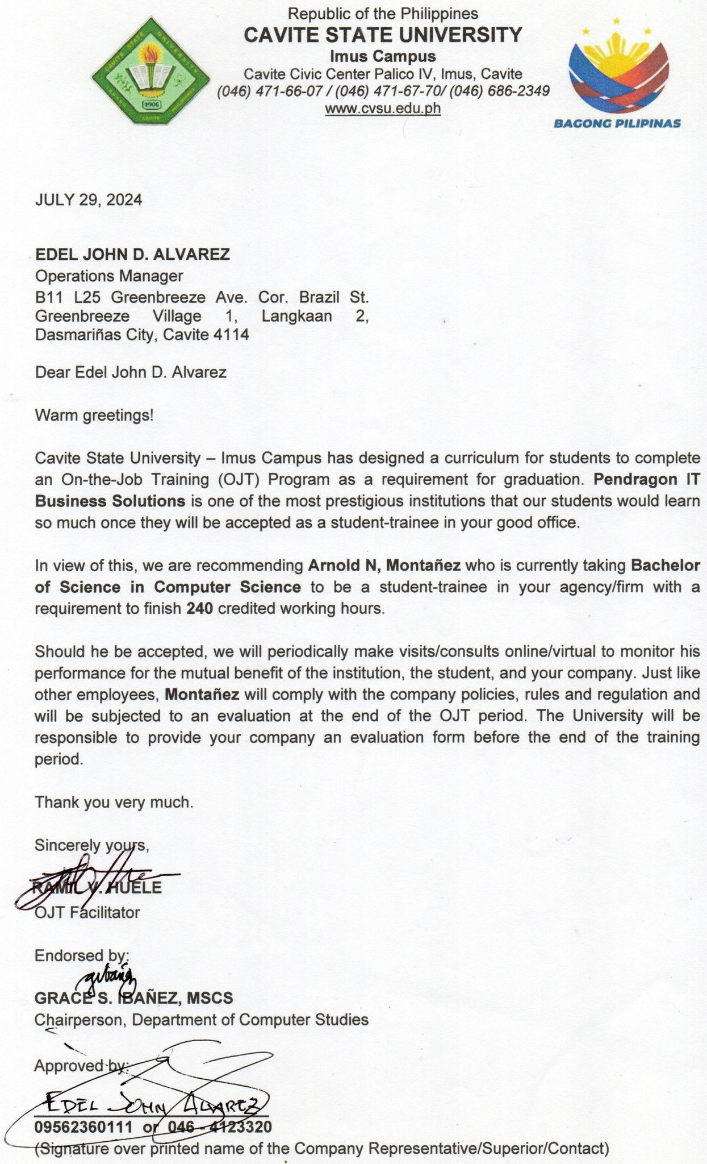

**Memorandum of Agreement**

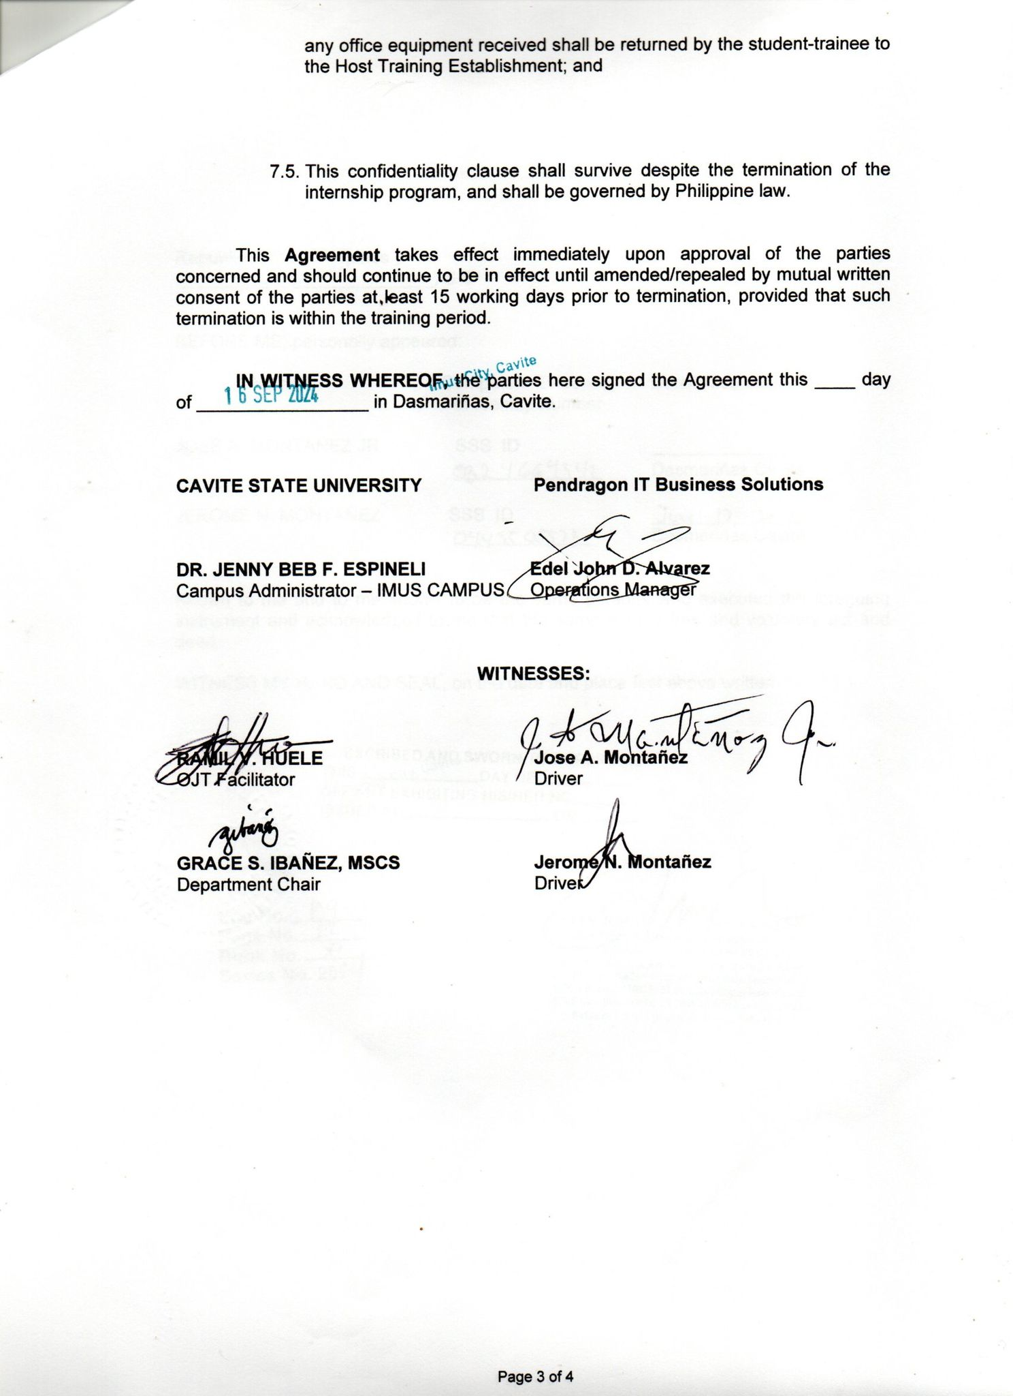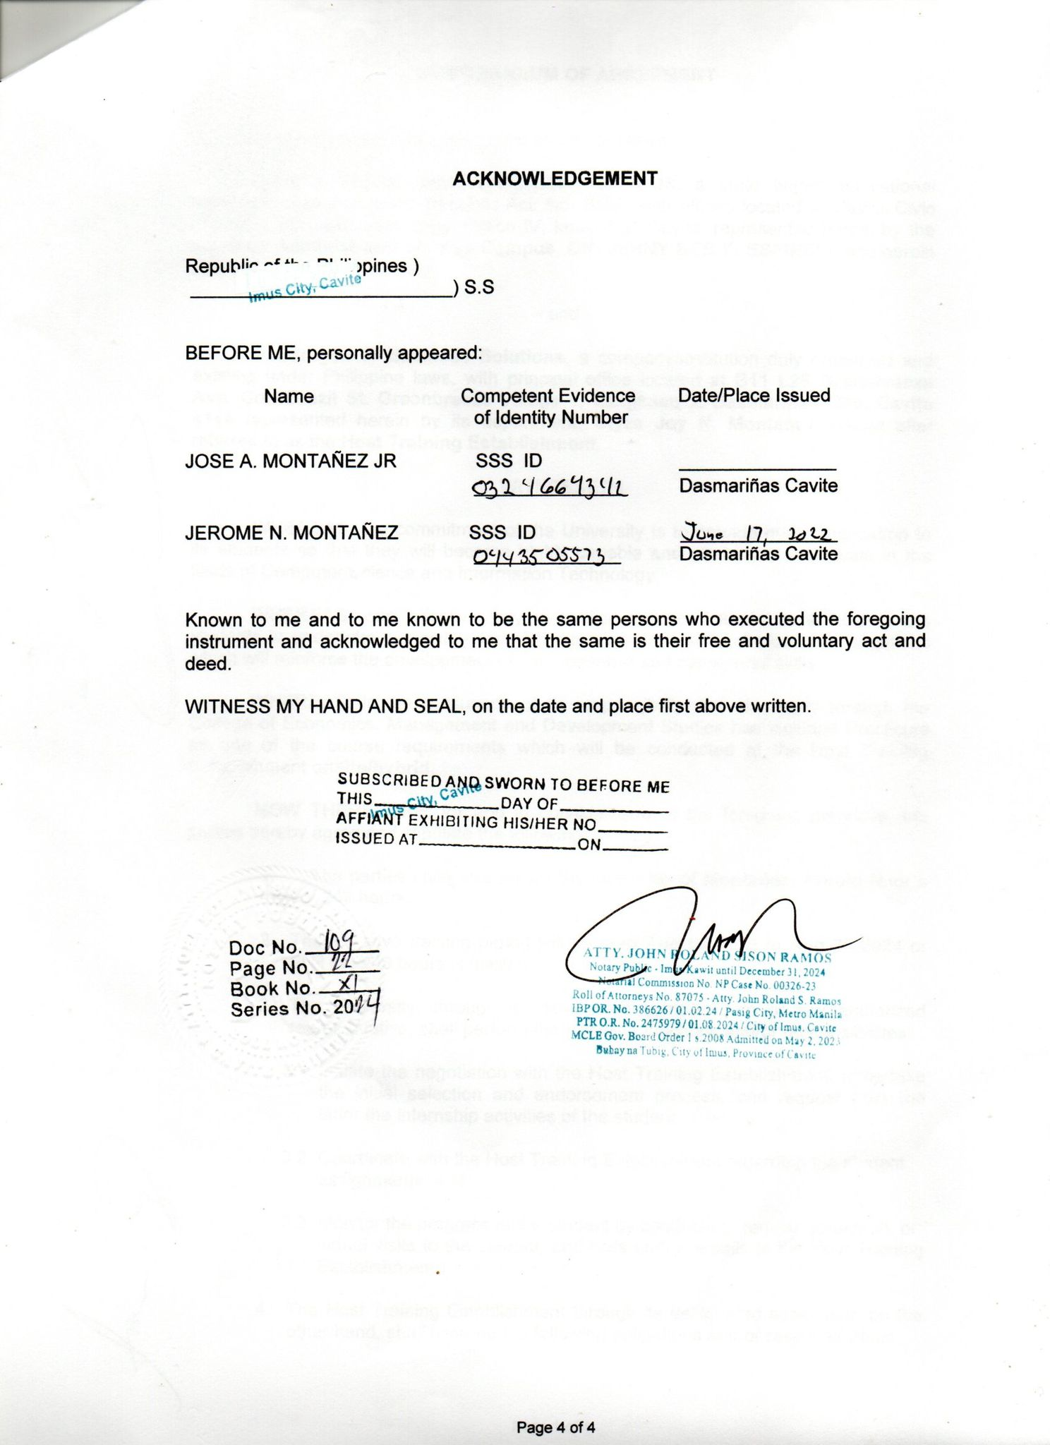

**Location Map**

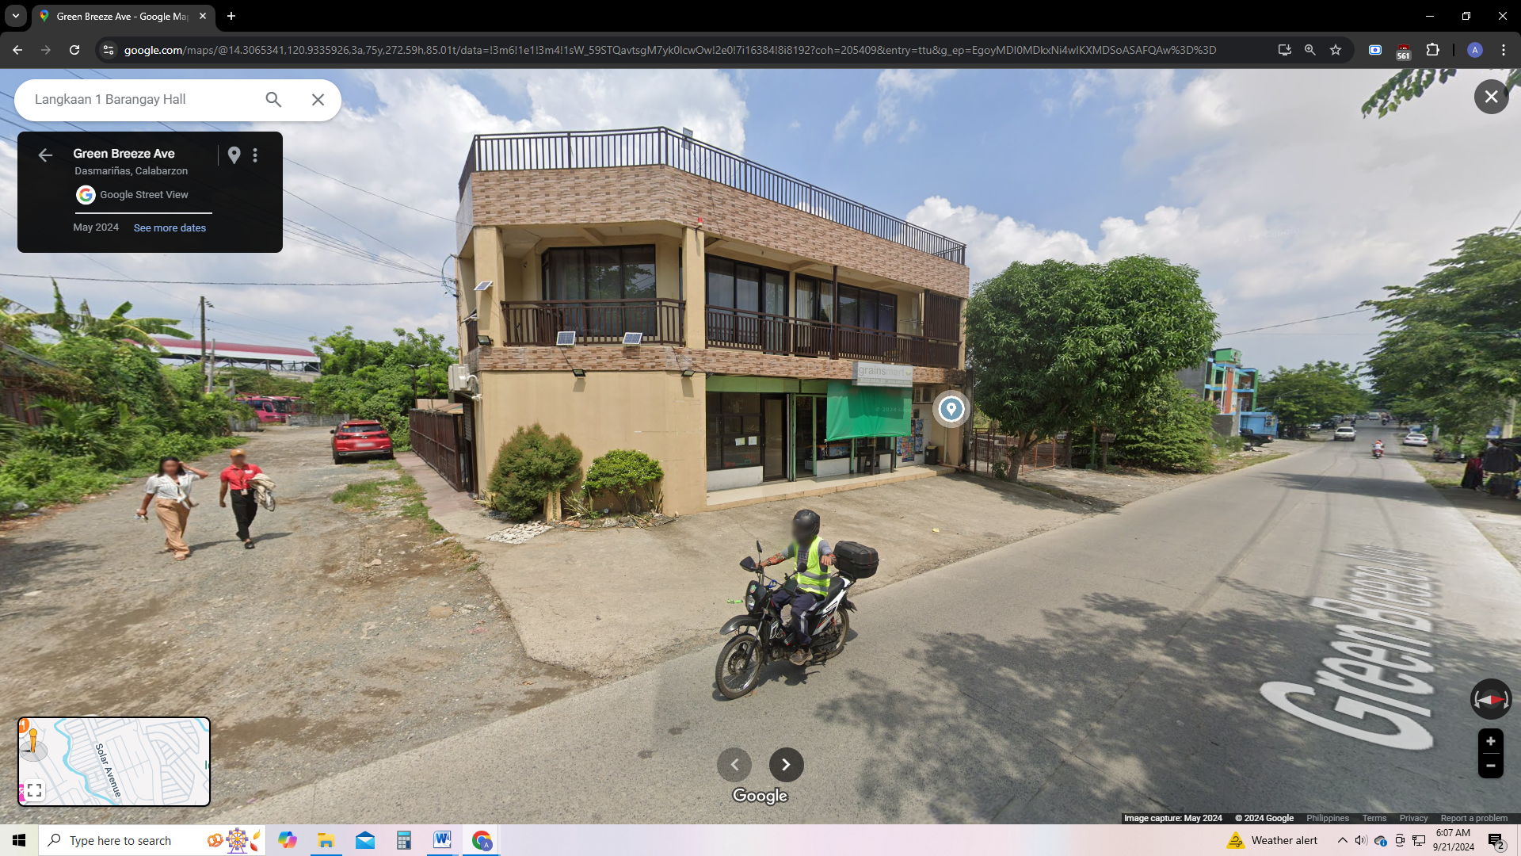



**OJT Placement Form**

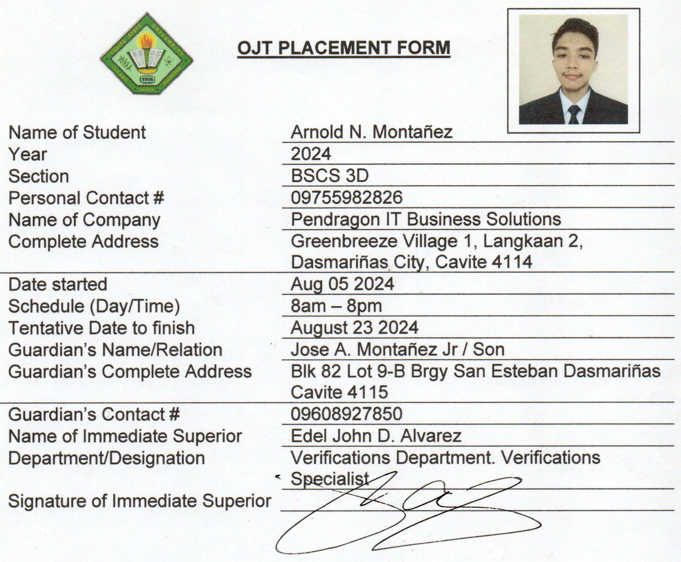

**Student Internship Pledge**

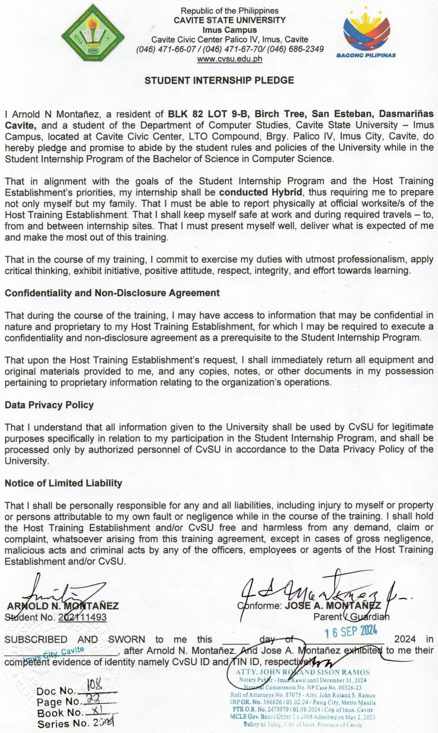

**Certificate of Completion**

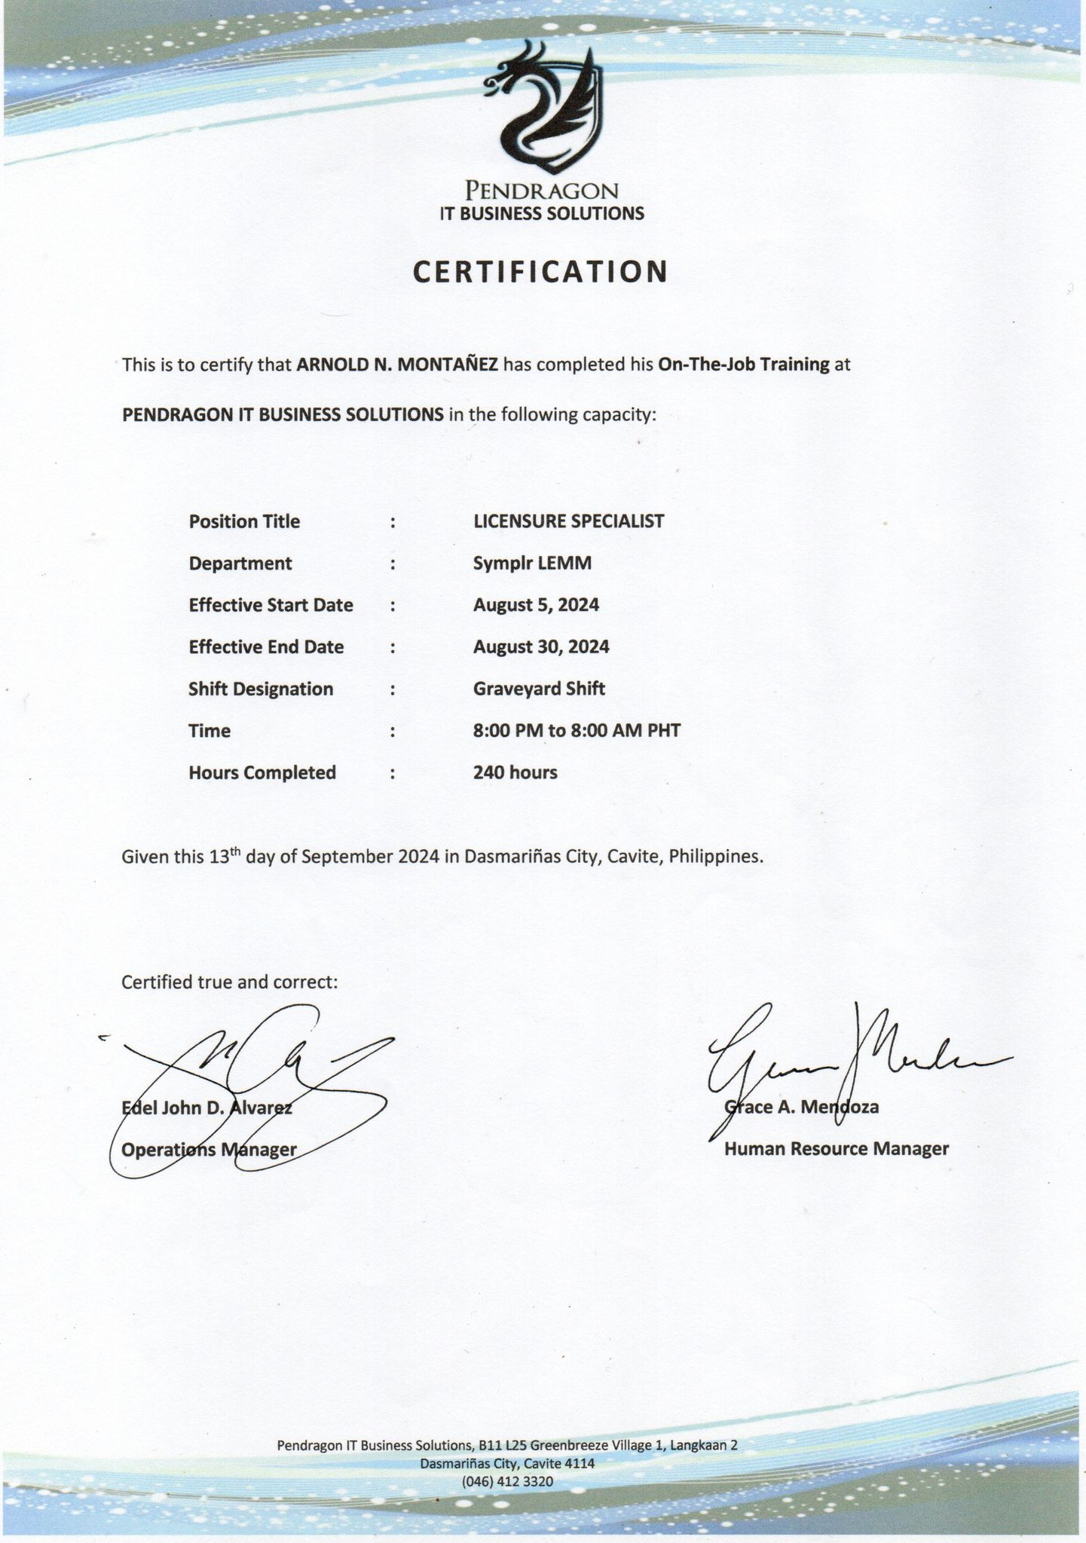

**Daily Time Record**



**On-The-Job Waiver**

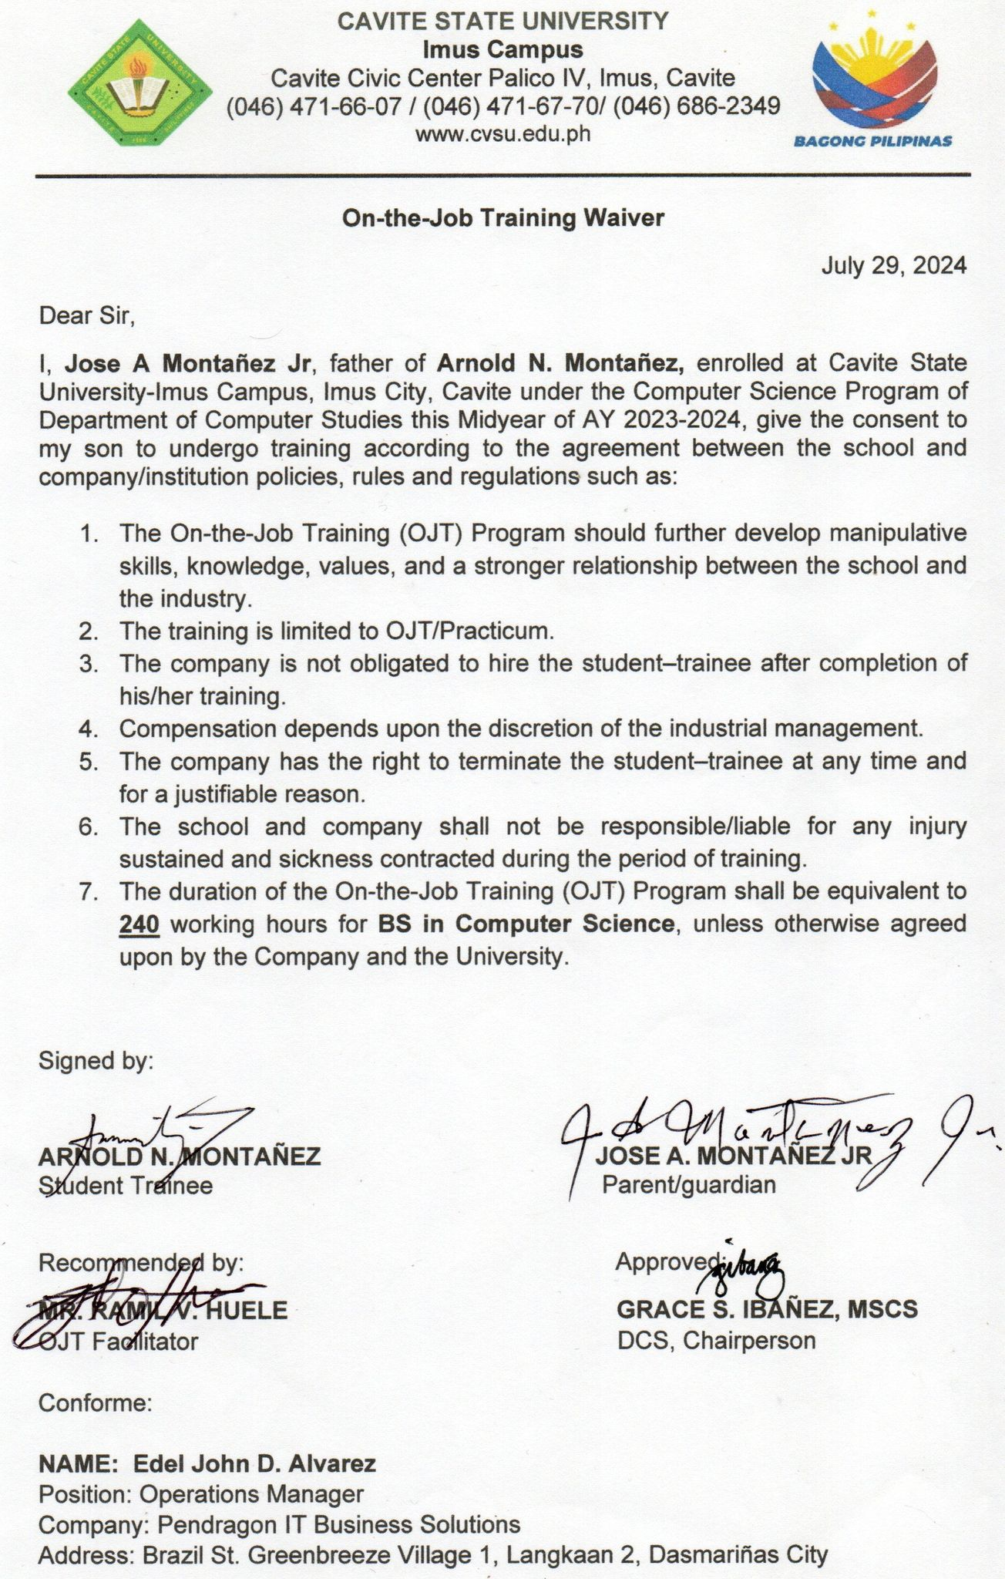

**Good Moral**



**Routing Slip**

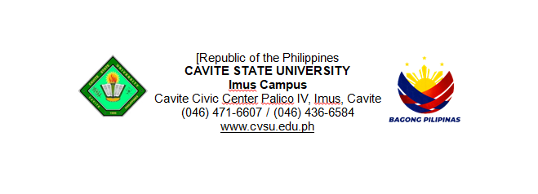

Department of Computer Studies

**ROUTING SLIP**

Author: **ARNOLD N. MONTAÑEZ**

Title: **A Narrative Report on Training Experience and Management Functions in a Hybrid Setup**

Type of the Study:

○ Thesis ○ EDP ○ Field Study ○ Narrative

|  |  |  |  |
| --- | --- | --- | --- |
|  | DATE  RECEIVED | DATE  RELEASED | REMARKS |
| **RAMIL V. HUELE**  OJT Facilitator |  |  |  |
|  |  |  |
|  |  |  |
| **GRACE S. IBAÑEZ, MSCS**  Department Chairperson |  |  |  |
|  |  |  |
|  |  |  |
| **JENNY BEB F.ESPINELI, PhD**  Campus Administrator |  |  |  |
|  |  |  |
|  |  |  |